**User Manual**

1. Unzip the TIANCHENLI-Submission.zip file to C: drive. The file structure should look like the below screenshot. The Data folder contains the SQL Database backup files.

1. Build api container and SQL container:

cd c:\Submission\Code\backend\

docker-compose build

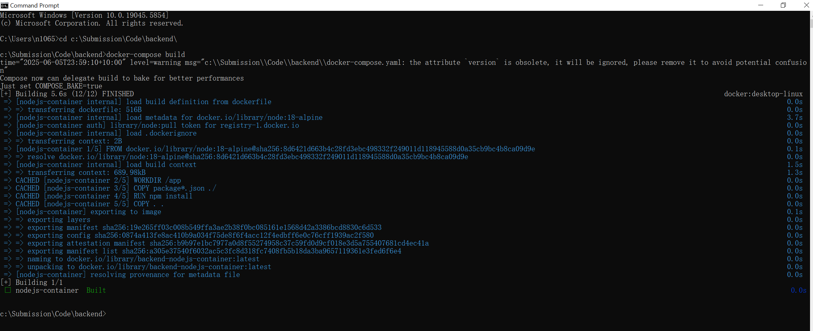

1. Run api container

docker-compose up

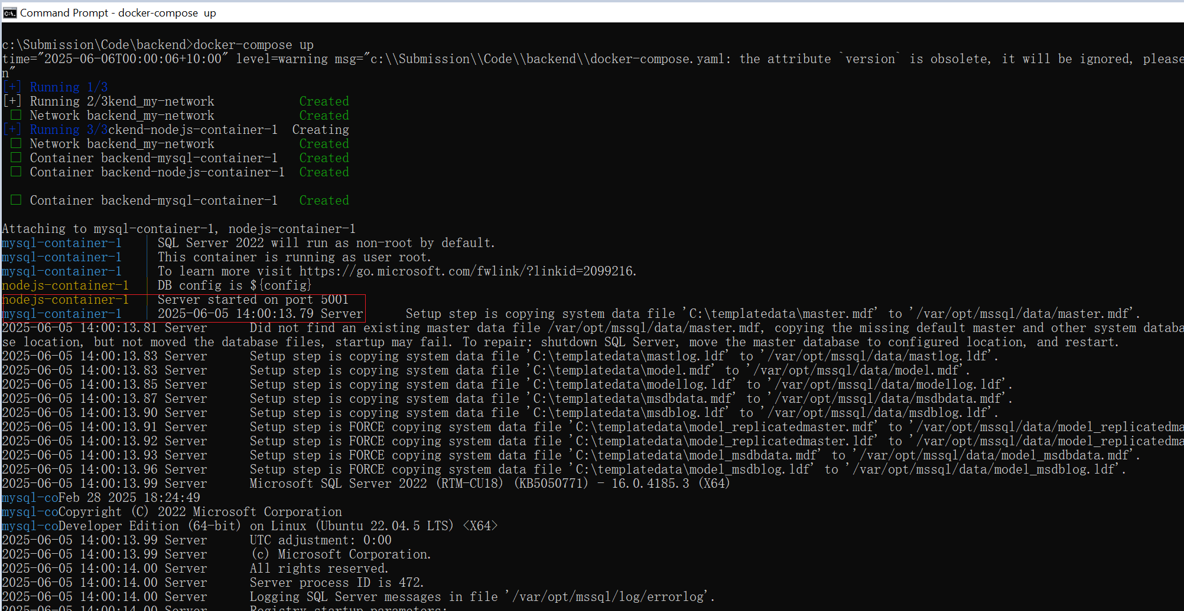

1. Run “docker ps” command and verify SQL container name is “backend-mysql-container-1”

1. Create database in SQL server container

* Copy MDF/LDF file to SQL container

docker cp C:\Submission\Data\MyDatabase.mdf backend-mysql-container-1:/var/opt/mssql/data/

docker cp C:\Submission\Data\MyDatabase.ldf backend-mysql-container-1:/var/opt/mssql/data/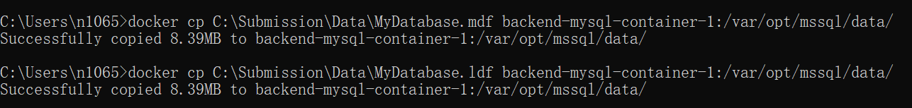

* Use AzureDataStudio or any IDE to connect to the SQL server to create database using the existing MDF/LDF files. (refer to the below screenshot for config values. User “SA” password is “Password123!”

* Attach the Database in Azure Data Studio. This is done by using following

query.

USE master;

GO

CREATE DATABASE MyDatabase

ON (FILENAME = '/var/opt/mssql/data/MyDatabase.mdf'),

(FILENAME = '/var/opt/mssql/data/MyDatabase.ldf')

FOR ATTACH;

GO

* Verify that database has been successfully imported.

USE MyDatabase

SELECT * FROM dbo.glb_Lookups

1. Build react.js container:

cd C:\Submission\Code\my-react-app\

docker build -t glb-lookup-app .

1. Run react.js container:

docker run -d -p 3000:3000 glb-lookup-app



1. Run application by <http://localhost:3000/>

Verify the glb-lookup-app container is running

